Dear {first_name},

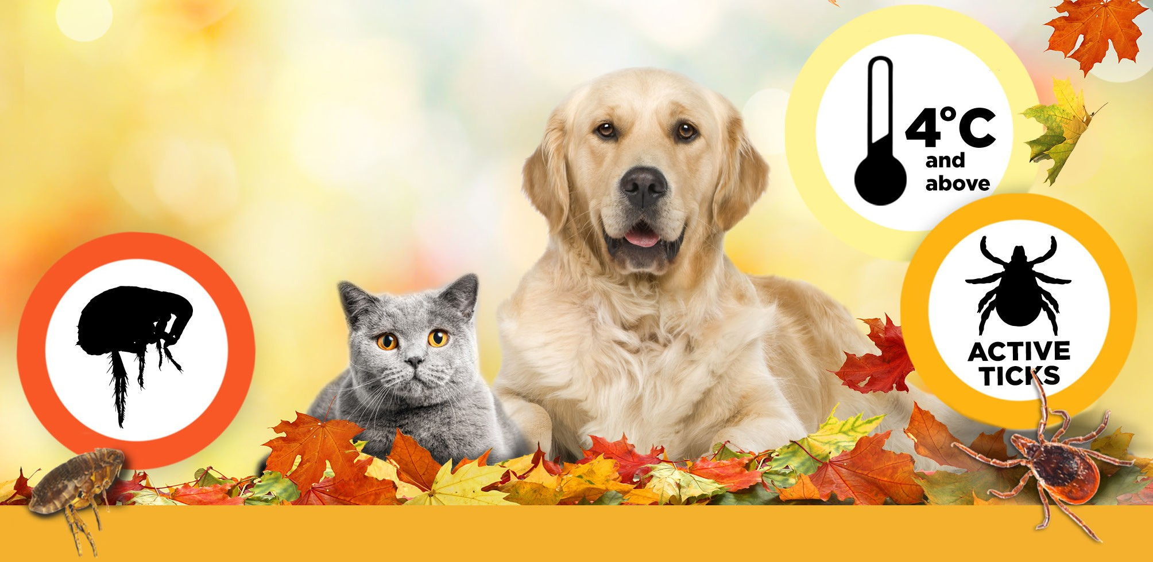

**Help protect {pet_name} against fleas and ticks this fall**

Fall is an important time for parasite protection. We see flea infestations peak in the fall and blacklegged ticks are out looking for a host when it’s 4°C and above, no matter what season it is. It is important that {pet_name} remains protected throughout the entire tick and flea period.

Our records indicate we prescribed **BRAVECTO®** for {pet_name}’s flea and tick control. If you need additional doses of **BRAVECTO®**, or if you have any questions, please contact us.

To learn more about **BRAVECTO®** you can contact us, or if you have the drug identification number (DIN), visit [Bravecto.ca](https://www.bravecto.ca/en).

{practicename}

{website}

 {contactemail}  {contactphone}

{add1}

{add2}

{town}, {province} {postcode}

Unsubscribe? Please click **here**.